GRAPH DATABASES AND ONTOLOGIES
Ivan Omelyanenko, Anna Bakurova, Elina Tereshchenko
National University "Zaporizhzhia Polytechnic"

Abstract. Text Text Text Text Text .......

Text of the article Text of the article Text of the article Text of the article Text of the article Text of the article.
Definition 1.
Theorem 1.

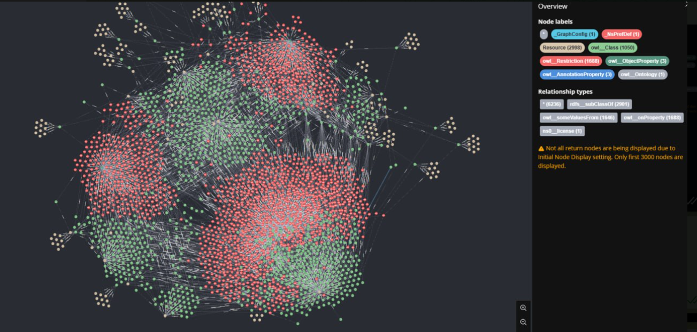
Fig.1 – Merging Two Ontologies by Neo4j

Figures must be neatly produced in any format supported by Microsoft Word; their dimensions must not exceed the text area. If a figure consists of several objects, they must be combined into a single object. All figures must be numbered and captioned as shown in the example. Figure captions should be in Times New Roman, 10 pt, italic. A blank line must follow each figure caption.
Equations must be entered using the built-in Equation Editor. Mathematical symbols for variables, both in the text and in illustrations, should be formatted as follows: Latin letters in italic; Greek letters upright; operator words (min, max, sin, cos, etc.) upright.
If any tables appear in the text, they too must be numbered and captioned. Table captions are placed in the upper left corner, as shown in the example. As with figures, both table headings and contents should be in 10 pt font. A blank line must follow each table.

Table 1
Heading

A bullet list is formatted according to the following rules:
− marker: a dash;
− indentations – as in the example;
− If there is a semicolon at the end of the line, then the following line begins with a lowercase letter. At the end of the bullet list, a dot is placed.
A numbered list is formatted as follows:
1. Numbers are depicted in Arabic numerals. Indentations – as in the example.
2. A period is placed after the number.
3. After the period, the text is capitalized. A period is placed at the end of the text.
When referring to a source, after mentioning it in the text, put in square brackets the number under which it is listed in the list of references, for example, [9].

Literature
It is designed in the APA style, for example:
1. Book: Author, J. P. (year of publication). The transliterated title of the book [Title of the book in English]. City State: Publishing House
Asaf'ev, B. (1980). Pro horovyi spiv [About the choral art]. Kyiv : Muzyka [In Ukrainian].
2. Periodicals: Author, J. P. (date of publication). The transliterated title of the article [Title of the article in English]. Transliterated Title of the periodical, Volume (Issue), Pages.
Get'man, V. V. (2013). Formation and development of anthropological tradition in the 11th-18th centuries. Innovacii v nauci, 19, 67–76, [In Ukrainian].
3. Electronic resources: Author, (date of publication). The transliterated title of the material is [Title of the material in English]. Source. Retrieved from: website address

