Ministry of Education and Science of Ukraine

Zaporizhzhya National Technical University Institute of Economics and Humanities
National TU Dnipro Polytechnic
Zaporizhzhya Chamber of Commerce and Industry
Poltava National Technical Yuri Kondratyuk University
Kujawy and Pomorze University of Bydgoszcz (Poland)
Tajik State University of Commerce (Tajikistan)
University of Rzeszów (Poland)
D. A. Tsenov Academy of Economics (Bulgaria)

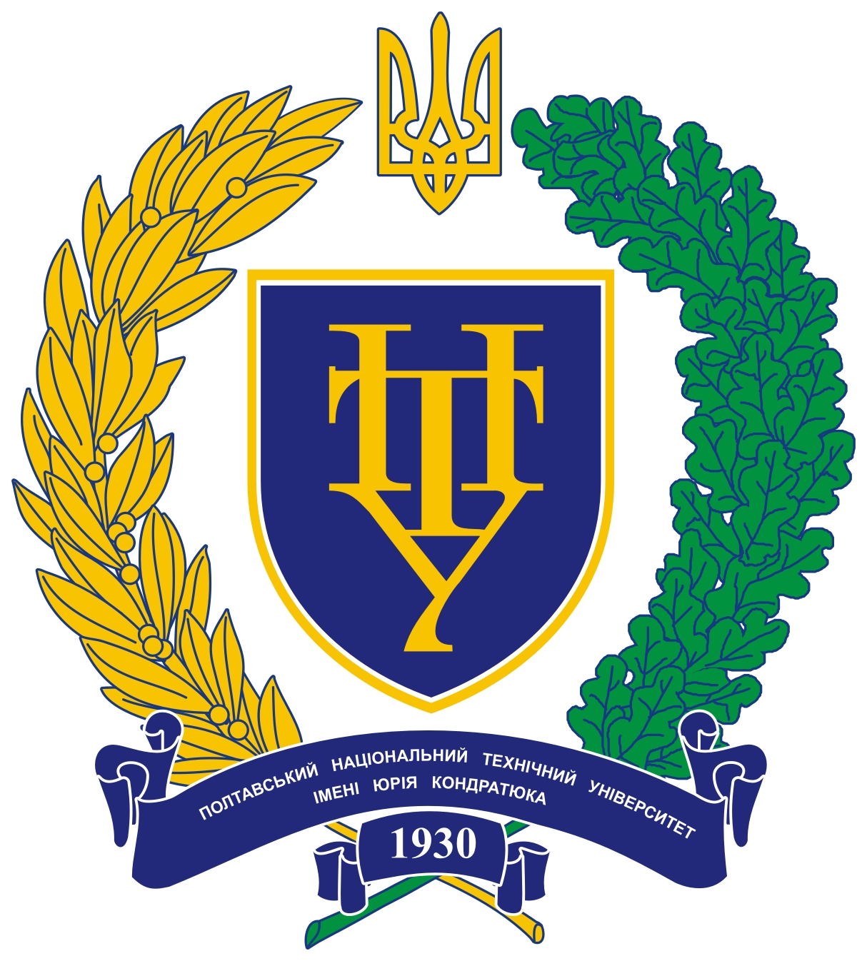
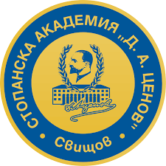

International Scientific and Practical Conference
“Inclusive Development Innovations Generation: the National,
Regional and International aspects”

October 4-5, 2018
Zaporizhzhia

Dear colleagues!

Dear scientists, lecturers, postgraduates, Masters, and representatives of business, governmental and public institutions! We invite you to participate in the International scientific and practical conference “Inclusive Development Innovations Generation: the National, Regional and International Aspects”, which will be held on October 4-5, 2018 in the Institute of Economics and Humanities, Zaporizhzhia National Technical University.

Themes of workshops:
1. Theoretical and methodological aspects of inclusive development: economic and sociocultural parameters.
2. The global aspect of economy inclusive development.
3. Economy of inclusive development: financial and credit, accounting and analytics support.
4. Marketing and logistics instruments of innovative inclusive development.
5. Public management of regional inclusive development.

Languages available: Ukrainian, English, Russian, Polish.
TERMS AND CONDITIONS

DEADLINE
- September 10, 2018. Fill in the electronic application form for authors.
- September 20, 2018. Send your 3 pages abstract to email zntu.conf@gmail.com
You MUST indicate the number of chosen workshop in the topic of your email (Name your file in Latin according to your surname and initials; include the word “abstract” in the second part of the file name (for example, Ivanov I.I._abstract).
The Organization committee will send a confirmation letter within 2-3 days. We will also send you payment details.
You should send a payment check copy to the email of the Organization committee (Name your file in Latin according to your surname and initials and include the word “kvitantsiia” in the second part of the file name (for example, Ivanov I.I._kvitantsiia).
Conference fee is 100 hrn. (The Conference program, electronic version of the Conference proceedings and the Certificate of the Participant included).
We do not cover any travel and accommodation expenses.

ABSTRACT FORMATTING
- 3 pages of Abstract (А-4 format, Text editor MS WORD / OFFICE, Times New Roman 14 pt, 1.5 line spacing, indentation – 1,25 сm (Please do not create a paragraph indent using Tab or spaces); Margins (top, bottom, left, right) – 2 cm, the text should be entered in justified alignment without hyphenation. Do not number the pages.
- The abstract should be structured as follows:
- The first line – Theme of workshop, aligned at the top right;
- A blank line;
- The next line – author’s name and surname, highlighted in bold and aligned at the top right;
- The next line – name of the institution and the city;
- A blank line;
- The next line – abstract title, typed in capital letters, highlighted in bold and centered;
- A blank line;
- The next line – text, Format – Alignment – Justified;
- A blank line;
- The next line – the list of used literature sources, numbered consecutively in order of citation and named “References”.
- put all references in the text into brackets, separate the sequence number of the references and the page with a comma, for example: [5, p. 57-61].
Format references according to the Ukrainian bibliographic description standard (ISO 8302:2015: References. Terms and rules of assembly. Kyiv, 2016). Access mode: http://zakon2.rada.gov.ua/laws/show/z0155-17).

Structure your Abstract as follows: rationale, general discussion, conclusions, references.
You should proofread your abstract together with your supervisor. The Editorial board can make some corrections in case of the given terms and conditions violation.
The author is responsible for the content and uniqueness of the given material.

ABSTRACT FORMATTING EXAMPLE

Workshop 2. The global aspect of economy inclusive development

Dr. Econ, Associate Prof. O. V. Kyrychenko
Zaporizhzhya National Technical University, Zaporizhzhia

AGRICULTURAL BUSINESS AS AN INTERATIVE PART OF RURAL TERRITORIES INCLUSIVE DEVELOPMENT
Text

References

THE ADDRESS OF THE ORGANIZATION COMMITTEE
of the International Scientific and Practical Conference
“Inclusive Development Innovations Generation:
the National, Regional and International Aspects”

Institute of Economics and Humanities
Zaporizhzhia National Technical University
64, Zhukovskogo Str., Zaporizhzhia, Zaporizhzhia Reg., Ukraine, 69063

Designated persons according to the workshops

№ | Workshop | Full name of responsible persons | Tel. number
1 | Theoretical and methodological aspects of inclusive development: economic and sociocultural parameters. | Nataliia Oleksandrivna Afendikova | +38(066)166-31-11
 |  | Olha Valeriivna Bondarenko | +38(066)581-63-07
2 | The global aspect of economy inclusive development. | Tetiana Serhiivna Pavliuk | +38(050)557-44-50
 |  | Kateryna Hennadiivna Chernomaz | +38(050)752-80-58
3 | Economy of inclusive development: financial and credit, accounting and analytics support. | Iryna Yakivna Maksymenko | +38(067)760-28-56
 |  | Oleksandra Pavlivna Zoria | +38(096)255-44-04
4 | Marketing and logistics instruments of innovative inclusive development. | Halyna Valentynivna Kozytska | +38(050)518-79-27
 |  | Vladyslava Vitaliivna Lyfar | +38(095)908-24-21
5 | Public management of regional inclusive development. | Oksana Oleksandrivna Sorina | +38(066)227-36-57
 |  | Tetiana Veniaminivna Pulina | +38(066)176-75-82

